3rd ANNUAL
DUVALL FIRE FIGHTERS ASSOCIATION
ART CONTEST
We had so much fun and success from last year’s contest, that we are trying to make this an annual event. The Duvall Fire Fighters Association (DFFA) is asking you to submit a design that we may use to incorporate onto T-shirts, hats, coins and other possible items to represent the DFFA. We will be selling challenge coins at this year’s pancake breakfast that have both first and second place winner’s artwork from last year.
INCENTIVES
- 1ST PLACE WINNER: $50 I-TUNES GIFTCARD
- 2ND PLACE WINNER: $25 I-TUNES GIFTCARD
GUIDELINES
- MAKE IT FIRE SERVICE RELATED (LADDERS, AXES, FIRE HOSE, MALTESE, HELMETS, FIRE… etc.)
- DESIGN MUST INCLUDE “DFFA” or “DUVALL FIRE FIGHTERS ASSOCIATION”
- NO MORE THAN 3 COLORS IN THE DESIGN
- TRY NOT TO PUT TOO MUCH SMALL DETAIL IN IT (harder to reproduce in coins and prints)
- WE MAY HAVE TO ALTER/ADJUST DESIGNS TO WORK WITH REPRODUCTION REQUIREMENTS
- HAVE FUN!!

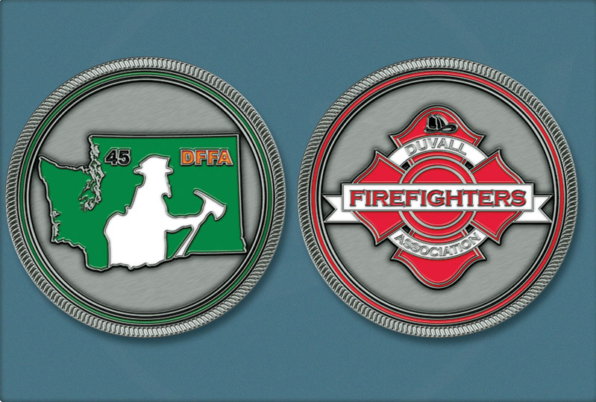
FIRST YEARS WINNING ART!!

